**FIT3179 Data Visualization – Semester 2 2022**

**Assignment 2**

**URL to visualization:**

<https://hmq1812.github.io/FIT3179-Assignment2/>

*Word count: 978*

*October 2022*

# Domain, Why and Who

The domain used in this visualization is World Population from 1950 to 2021. Each nation in the world has a different population, growth rate, and area, … Therefore, exploring the population of countries in the world in the past 70 years revealed many interesting findings. The targeted audience of the visualization is people who are interested in finding information about our world, including data from the past and predictions of the future.

# What

The data used in this visualization is "Population and Demography" (United Nations, 2022), collected and published by the Population Division, Department of Economic and Social Affairs of the United Nations. The dataset is a 2D table, containing 18298 records of all countries and regions in the world from 1950 to 2021. Most of the attributes are quantitative, for example, population, population under 1-year-old, population under 5 years old, … The country name attribute is categorical, and the year attribute is ordinal data. Before using this dataset for visualizations, I had to rename the attributes so that they can be easily referred to in the code. After that, I performed several transformation steps such as calculating changes in populations and calculating the population of the world to produce certain graphs and charts.

# Why and How

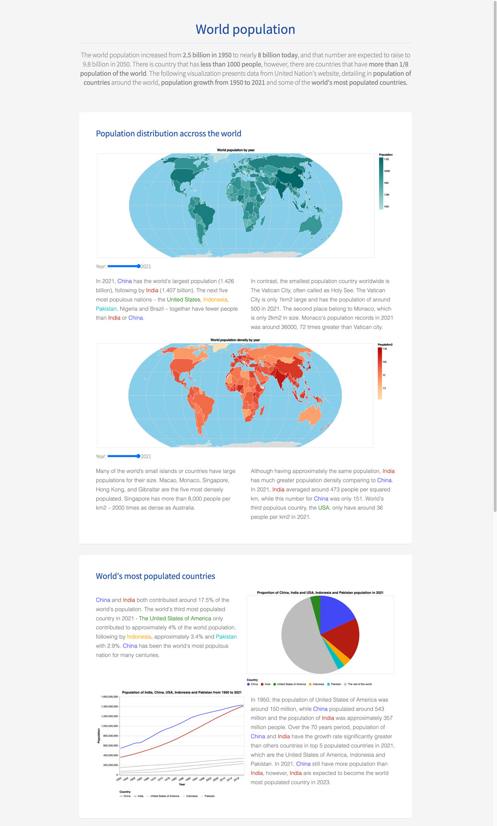

Figure 1: Entire visualization (1)

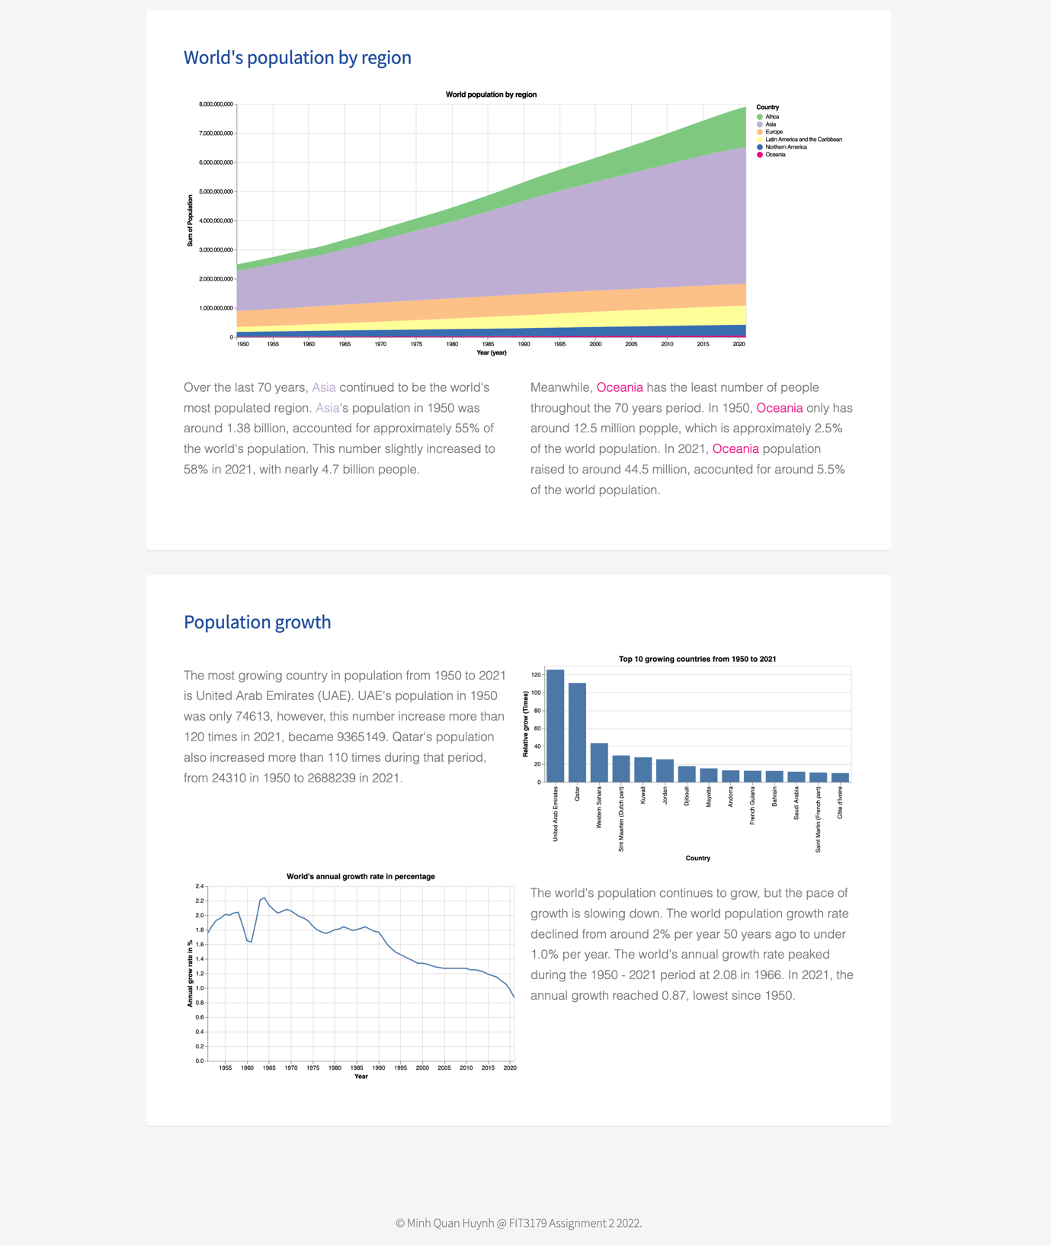

Figure 2: Entire visualization (2)

Figure 3: World map showing number of populations in each country, filtered by year

Figure 4: World map showing number of populations density in each country, filtered by year

In Figures 3 and 4, the main actions I want to perform are presented and compared. To accomplish the actions, I used color value as the channels used are length for this visualization. Color values are used to represent the number of populations in a country (Figure 3) or the number of people per one-squared kilometer (Figure 4). Using a map allows the viewer to easily compare values for different countries and figure out the common factors for each region. The viewer can also select to view the population and population density for one particular year between 1950 and 2021.

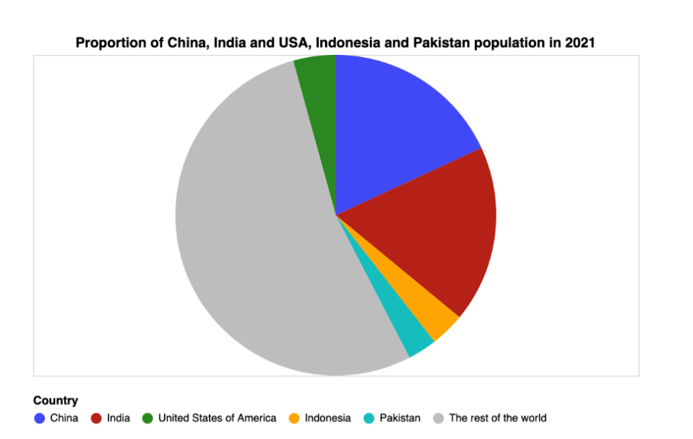

Figure 5: Pie chart showing proportions of population of world’s top 5 populous countries

In figure 5, I wanted to present and compare the population of the 5 most populous countries in the world to the rest of the world. By doing so, I was able to point out that India and China contribute a large proportion to the world's population and these two countries have many times more people than the others. The mark used in this chart is area and the channel used are area and color. The area is used to show the population in 2021 and color is used to represent different countries. A pie chart was chosen as it highlights the difference in population.

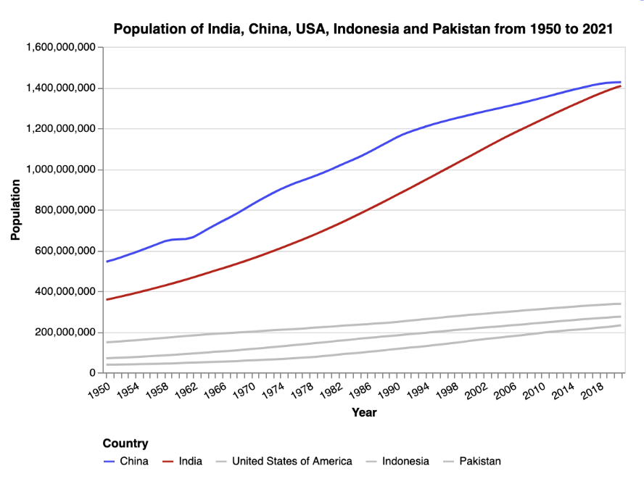

Figure 6: Line chart showing population of world’s top 5 populous countries throughout the years.

In figure 6, I want to present and compare the population of China and India over 70 years. The mark used in this visualization is the line and the channels used in this visualization are color and position. Color is used to represent different countries and position is used to represent the population in a year. As I wanted to highlight the growth over the years and compare the difference between these two countries and others, a line chart is chosen. Using gray to represent the USA, Indonesia and Pakistan helped highlight the countries that I wanted to focus on, which are India and China.

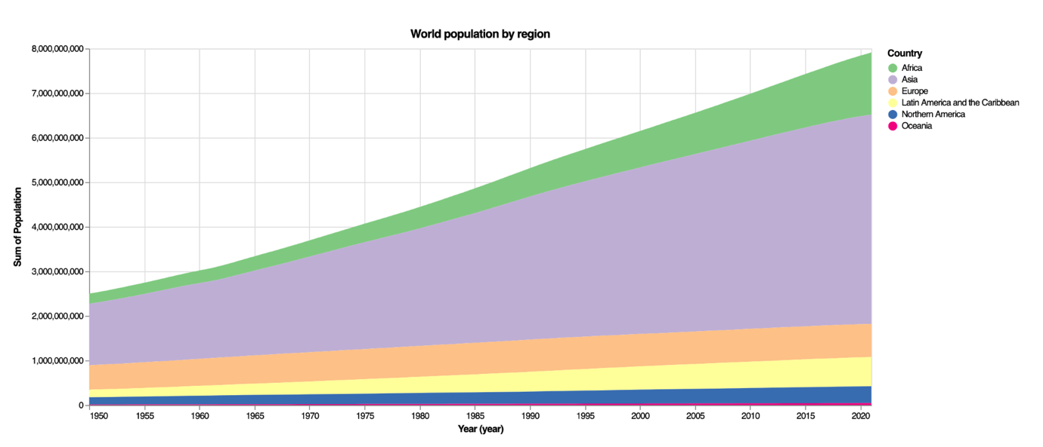

Figure 7: Area chart showing the world’s population by regions.

In figure 7, my primary focused actions are present and compared. The area is used as the mark in this chart and a channel used is the area, showing the population of a region in a specific year. Another channel in use is color hue, which distinguishes between different parts. This area chart allows users to compare different regions as well as compare one region with the total world population in a year.

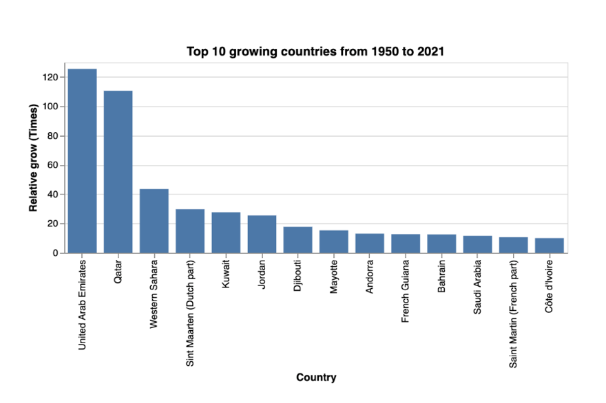

Figure 8: A bar chart showing top 10 growing countries from 1950 to 2021.

In this figure, I want to present and compare information about the top 10 growing countries from 1950 to 2021. The mark used in this map is a line and the channel used in this map is length. The length of the bar contains information about the relative growth rate of a country, measured by times. This bar chart is sorted hence a user can easily find information about the growing countries.

Figure 9: A line chart showing the world’s annual growth rate from 1950 to 2021

Figure 9 presents information about the world's annual growth rate, measured in percentages. The mark used in this channel is line while the channel used is position. The channel represents information about the annual growth rate of the world in a particular year. Using a line chart for this type of data allows users to conclude the growing trends and gain insight from it.

# Design

In terms of layout, I divided the structure into 2 rows for the heading and 7 figures. Horizontal sightlines are used to septate visualizations into different sections. Each section is divided into a smaller grid for charts, graphs, and text using more sightlines. The symmetrical balance is maintained throughout the whole website by using a consistent 2 columns layout.

White and light grey are mainly used in this visualization to maintain a clean and minimal look. I used a white box on top of the light grey background to create a floating effect and to make the sections separate from each other while standing out from the background. Consistent color is used to represent the same country throughout the whole website. For example, in Figures 5 and 6, blue is used to represent China and red is used to represent India. I also used the same color encoding when mentioning these countries in the description text.

I selected brighter colors for the figures and neutral colors for the background to draw attention to the important elements. Additionally, I utilized smaller and lighter fonts for captions and bigger and bolder fonts for titles and headings. On top of that, I also used a completely different text color for the titles are heading. To reduce complexity and confusion in the visualizations, I categorized the less significant graph components as "Others" and represented them using light grey.

A San Serif typeface was used in this visualization. The clean and crisp lines of Sans Serif fonts help improve the readability, especially for on-screen use such as the website. Important information, like country names, is highlighted in captions using color coding and font-weight. I also strictly followed the 10 words per line rules to make the texts easier to read, and carefully aligned text blocks with figures to preserve a consistent layout.

In terms of storytelling, I provide a succinct summary for each graph to explain the message and deliver key findings from the figure. Figures are also grouped into different sections based on the content to further clarify the message.

# Appendix

# Reference

Department of Economic and Social Affairs of the United Nations. (2022). *Population and Demography* [Data file]. Retrieved from <https://population.un.org/wpp/Download/Standard/Population/>

# 5 Design Sheets